Ad hoc Reporting Administration – Help

**Lydia Lim’s cheatsheet – For internal Accela use only**

Turn on *Navigation Pane* to see table of contents (Menu Bar > View > Navigation Pane)

AHR = Ad Hoc Reporting

# Logo (Global)

* A logo image appears on the top-left of every tabular report (and all embedded tabular subreports, if used). If the agency doesn't upload a logo for AHR, AHR uses the Accela logo by default.
* To upload a logo to be used instead of the Accela logo on all AHR reports: See AA 7.3 Administrator Guide page 255: **Applying a Logo to Ad Hoc Reports**
  + Configure the Standard Choice LOGO_TYPE_CATEGORY to include the Standard Choices

Value AGENCY_LOGO.

* + Go to: v360 Admin > Agency Profile > Logos > New. Select Logo Type of AGENCY_LOGO. Upload the Logo image file and click Save.
* The Global Logo cannot be removed. It appears in all reports and subreports, including embedded subreports.
  + Workaround to remove logo: Upload a blank PNG image file as the AGENCY_LOGO, making it small in size. Example:  
    
  + See Steps above for uploading.

# Migrating Reports between Environments

* Before AA 8.0, AHR reports can’t be moved between environments, except if client is self-hosted and there is complete data restore from one environment to another.
* With AA 8.0 (Oct 2015), Data Manager handles transfer of Ad Hoc Report definitions between environments.

# Report Manager

See *Report Manager and Ad Hoc Reporting Help.docx* in Report Manager Integration folder.

# Views

## Exposing Views to Ad Hoc Reporting Data Sources page

### When custom views aren't used

* Use this setting by default for new hosted agencies. As of April 2015, Accela-hosted agencies cannot use custom views for AHR.
* Don't configure Standard Choice ADHOC_REPORT_DB_VIEW or add views to it
* **Complete** set of default views will then appear in Report Manager > Settings > Ad hoc Report Data Sources  
  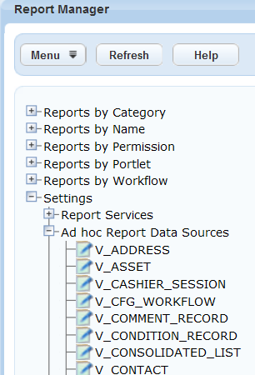
* To expose views to AHR Data Sources page, permission must be manually set for each View in Report Manager - by Module or User Group.

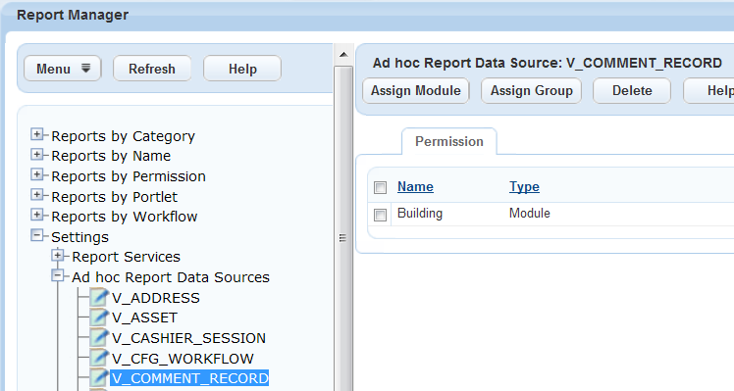

### When custom views are used

* Standard Choice ADHOC_REPORT_DB_VIEW must be used to list all view names that will be exposed to AHR. Names of standard views must also be added here.
* The list of views in above Standard Choices will appear in Report Manager > Settings > Ad hoc Report Data Sources.
* Must manually set Permissions for each View in Report Manager - by Module or User Group

From official documentation:

Configure the Standard Choice ADHOC_REPORT_DB_VIEW to define which data sources (DB Views) are available for ad hoc reporting. If you did not configure the Standard Choice yet, Accela Automation uses a default list of DB Views. See [Standard Choices Reference](https://av.supp.accela.com/portlets-help/accelaautomationdocumentationset/docset1/accela_automation_configurers_guide/aa_ref_standard_choices/standard_choices_reference.htm#XREF_34929_Standard_Choices) for more information.

■ Open Report Manager (Settings > Ad hoc Data Sources) and assign permissions either by user group or by module for each data source. See [Setting Permissions on Ad hoc Report Data Sources](https://av.supp.accela.com/portlets-help/accelaautomationdocumentationset/docset1/aa_admin/aa_admin_report_manager/assigning_permissions_to_reports.htm#XREF_12573_Setting) for more information.

## Default Views - New

* Added by Engineering after initial AHR release
* Not in Data Dictionary (which only contains initial set of default views that Lydia created)
* List:
  + V_ASSET
  + V_CONTACT_ADDRESS - for multiple contact address functionality
  + V_WORKORDER_ASSET

## Unknown Default View in Report Manager

* Observed in Oakland's Support site, AA 7.3 FP1, March 2014
* No standard choice ADHOC_REPORT_DB_VIEW configured
* View below not in DB (exposed to User1), not created by Lydia
  + **V_CONSOLIDATED_LIST**
    - If enabled - appears in AHR, but no fields in dropdown